Abstract
- Characterized the Allo functional simulator's compilation and execution pipeline (Python DSL → Allo MLIR → OpenMP MLIR → LLVM IR → JIT) across systolic-array configurations from 2×2×2 to 16×16×8 (16–324 PEs).
- Identified that build time dominates total runtime (~87%) and that OS thread scheduling consumes >95% of simulation time; customize() is the single largest build cost at 51% of build time.
- Reproduced the prior AXI-Stream + interconnect vadd example as a systolic-array example, replacing point-to-point handshaking with packet-routed PE communication to demonstrate the Allo path end-to-end.
- Established a head-to-head against Vitis HLS C-simulation: the Allo simulator wins decisively at small scale (8.4× at 2×2×2), reaches parity around 10×10×8, and is overtaken by HLS at larger scale (HLS 1.8× at 16×16×8).

Contribution
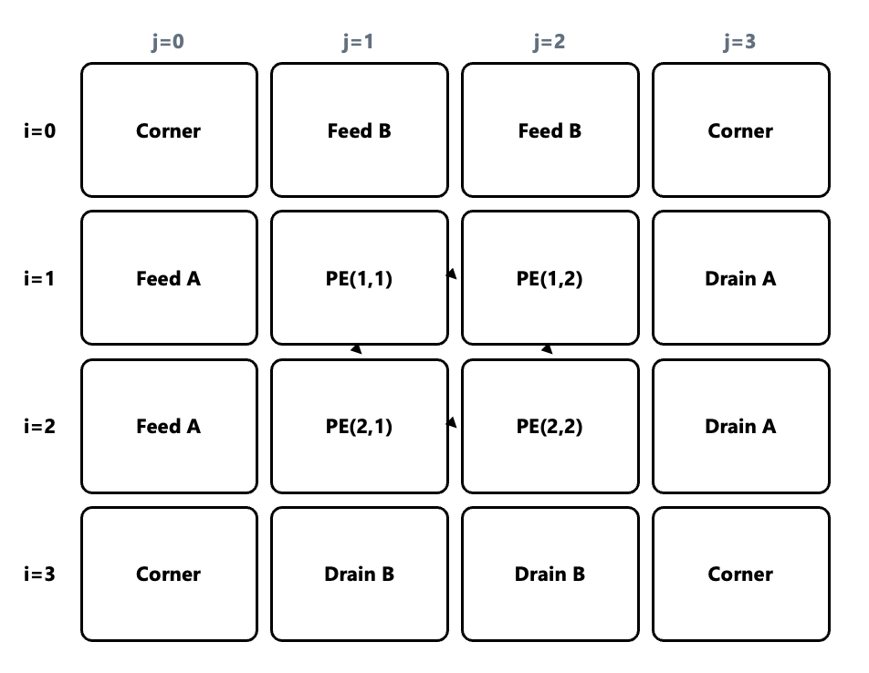
Figure 1: Systolic Array structure
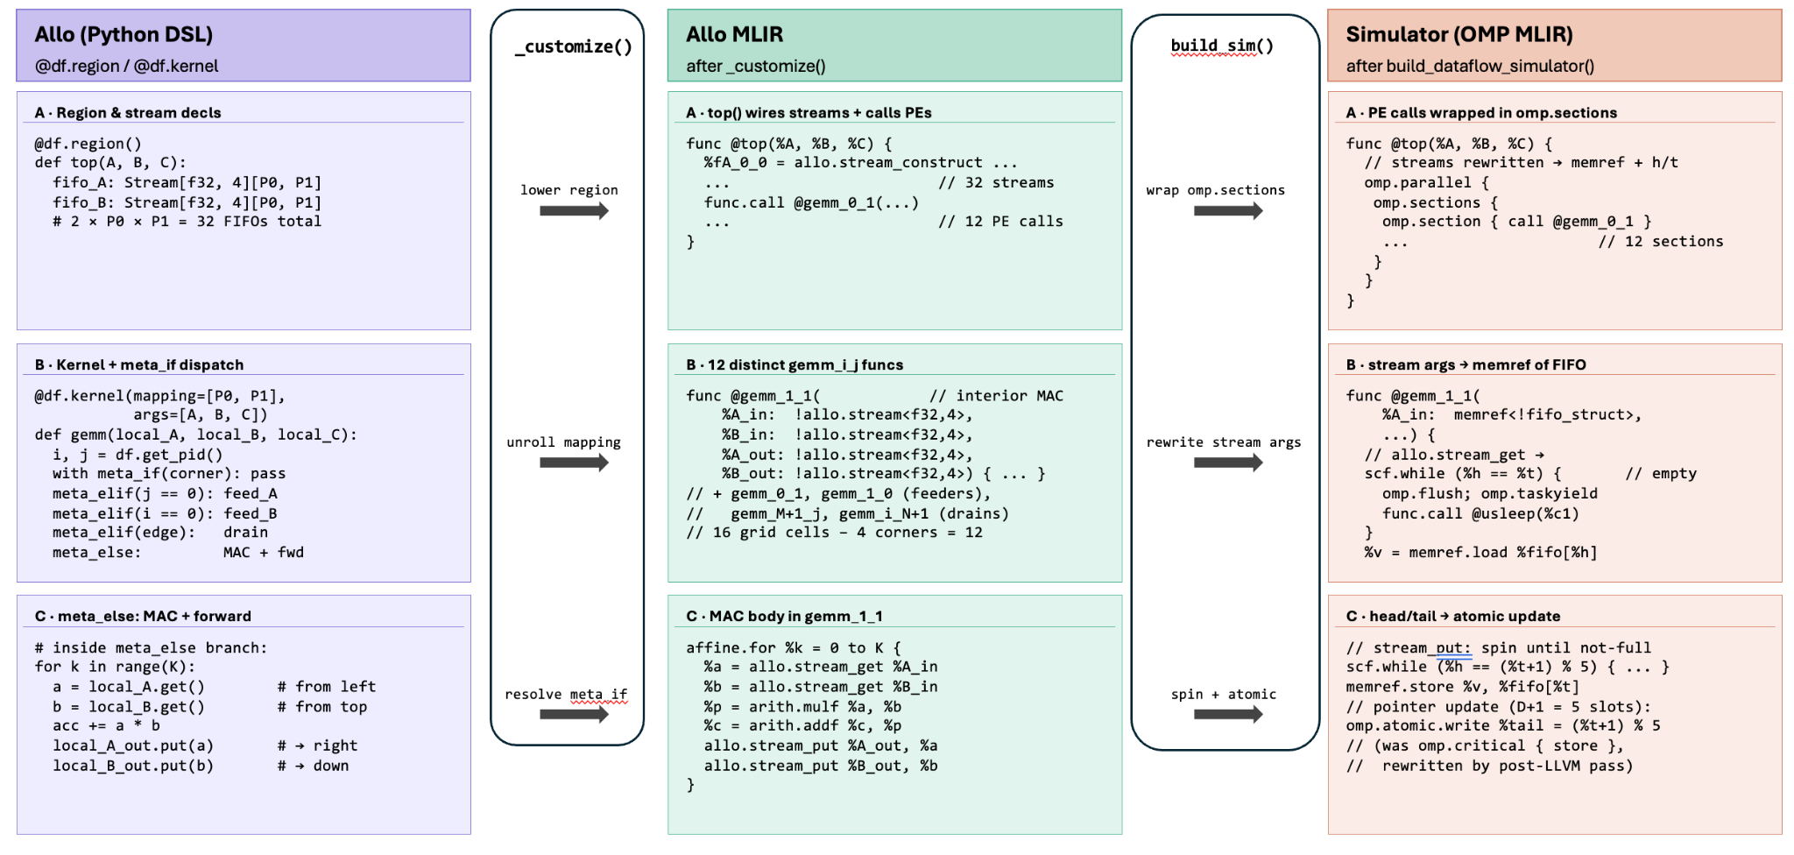
Figure 2: Allo systolic-array example, three representations in Allo, Allo MLIR, and simulator

How the simulator is organized (5-stage pipeline)
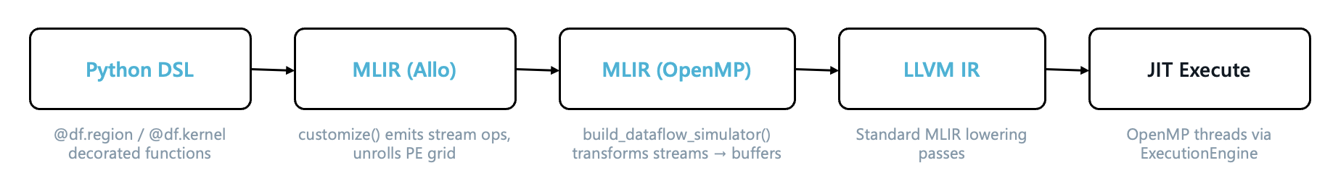
Figure 3: Simulator pipeline
The simulator lowers a high-level dataflow description into a multi-threaded native binary in five stages. In the first stage, the Python DSL creates the systolic array using region and kernel indicators, and the role of each processing element, whether it sits in a corner, feeds A or B, drains A or B, or runs the MAC, is selected at compile time. In the second stage, the customization pass walks the Python AST and creates one MLIR function per unrolled PE. In the third stage, the dataflow-simulator pass rewrites the module in place. Each stream is replaced by a struct holding three things: a circular buffer one larger than the declared depth, a head index, and a tail index. Every PE call is then wrapped in its own OpenMP section, and the section block sits inside a single parallel region. Each stream put and get is replaced by a busy-wait loop that checks fullness or emptiness, flushes memory, yields to the OpenMP scheduler, and sleeps for one microsecond between checks. In the fourth stage, the module passes through a standard MLIR lowering chain. A custom pass at the end of this stage rewrites every section containing only a store into a single atomic-write op, which is significantly cheaper to create and to execute. In the fifth and final stage, the JIT wrapper class links the MLIR runner utilities and libomp into the process and sets OMP_NUM_THREADS equal to the number of PEs whenever the host machine reports fewer cores than that.

Enabling large arrays: OMP_NUM_THREADS auto-sizing
Because the simulator wraps each PE in its own OpenMP section, every PE needs a dedicated thread to make progress. On the test host, the OpenMP runtime defaults to one thread per CPU core which gives sixteen threads total. A 16×16×8 systolic configuration produces 324 PEs, so under the default configuration only the first sixteen sections ever begin executing. The remaining 308 stay waiting in the scheduler queue, and the sixteen that did start immediately spin on stream reads from PEs that the runtime has not yet scheduled and will never get to. The simulator deadlocks before producing any output.
The fix is two lines in allo/customize/llvm_omp.py. The dataflow-simulator pass now returns the count of PE call sites it wrapped, and the JIT wrapper class checks this count against the host's CPU count during initialization. If the PE count is larger, it overrides OMP_NUM_THREADS to match the number of PEs. The override has to happen before the JIT execution engine is created, because libomp.so reads the environment variable exactly once when it is first loaded.

Systolic-array kernel with agents
Building on the AXI-Stream + interconnect vadd flow, I had a coding agent reproduce the same systolic GEMM kernel that tests/dataflow/test_systolic.py defines, M = N = K = 2 over a 4×4 PE mapping, with the four corner PEs eliminated.
The agent reused most of the infrastructure from the vadd flow directly. What the agent had to create for the GEMM case was a per-PE specialization into feed, MAC, and drain templates, a float32 to uint32 bitcast so a 32-bit AXIS lane could carry IEEE-754 values; the top-level wiring of all twelve internal AXIS edges as named hls::stream objects, mapping one-to-one with the fifo_A and fifo_B arrays Allo would have generated; and a result-packet protocol on each interior PE's output port for the C-matrix cell it computed.
The agentic flow at this shape took roughly thirty tool calls over five minutes and produced about 411 lines of HLS C++ (plus another ~130 lines of testbench and Tcl). The Allo source for the same kernel is 36 lines.

Benchmarking
Step | Time | %
customize() (Python → MLIR, PE unrolling) | 3.26s | 51%
JIT compile (ExecutionEngine) | 0.83s | 13%
lower_composite_type | 0.73s | 12%
build_dataflow_simulator | 0.62s | 10%
Pass pipeline (→LLVM+OMP) | 0.54s | 8%
Other (critical→atomic, bufferize, etc.) | 0.32s | 6%
Table 1: Build-time breakdown (8×8×8, 96 PEs, 6.34 s)

Component | % of sim time
OS thread scheduling (context switches, cache thrashing) | 95%+
usleep(1) spinloop wait | <1%
Computing | negligigble
Table 2: Sim-time breakdown, OS thread scheduling >95%; usleep(1) <1%; actual MAC compute negligible.
Config | PEs | Build % | Sim % | Build (s) | Sim Total | HLS Total | Winner
2x2x2 | 16 | 85% | 15% | 0.74 | 0.87 | 7.34s | SIM 8.4×
4x4x4 | 36 | 88% | 12% | 1.88 | 2.13 | - | -
6x6x6 | 64 | 88% | 12% | 3.77 | 4.30 | 9.07s | SIM 2.1×
8x8x8 | 100 | 87% | 13% | 6.34 | 7.29 | - | -
10x10x8 | 144 | 87% | 13% | 9.95 | 11.41 | 12.19s | ~tie
12x12x8 | 196 | 87% | 13% | 15.49 | 17.73 | 14.50s | HLS 1.2×
14x14x8 | 256 | 88% | 12% | 22.49 | 25.57 | - | -
16x16x8 | 324 | 88% | 12% | 31.99 | 36.32 | 20.15s | HLS 1.8×

Table 3: Configuration sweep + HLS csim comparison using int32 and single Matmul (PE counts use (M+2)(N+2) − 4 after corner DCE)
Discussion

Build time not simulation time is the bottleneck
Across every configuration in the benchmark, roughly 87% of the total time is spent before a single thread executes: the actual parallel simulation is comparatively cheap. The main cost is in the customization pass, which creates one MLIR function per PE. Because the systolic grid grows quadratically in its side length, so does the number of emitted functions, and so does the time the pass spends walking the AST and rewriting it. By the 16×16×8 configuration, this single pass accounts for over half of the build time.
Why HLS catches up
Both the Allo simulator and Vitis HLS C-simulation are CPU-bound; the difference is the constant factor in front. HLS csim runs the entire design as a single process and uses cooperative scheduling to move data between channels which means there is no kernel-level context switching in the inner loop. The Allo simulator takes the opposite approach by having one OS thread per PE, with the auto-sizing fix makes the thread count equals the PE count regardless of how many cores the host actually has. At small array sizes this is the right trade because the simulator wins by an order of magnitude at the smallest configuration because the per-PE overhead is negligible and the rest of the work is parallelized. At larger sizes, the same design becomes a limitation. By 144 PEs the simulator is running ten times more threads than the host has cores, and the OS scheduler spends most of its time moving threads on and off cores rather than executing the simulation itself.
Systolic array allo example
The agentic and compiler paths solve the same problem but pay for it differently. The Allo source is 36 lines and generalizes to any systolic shape by changing three constants. The agentic HLS source is shape-specific and grows linearly with the grid, at 2×2×2 it is already about 10× longer (411 lines), and the gap widens with size.
Vitis HLS csim runs in 0.18 ms while the Allo simulator takes 142 ms. The two are answering different questions, though. csim runs the design as sequential C++ to check that the arithmetic is right; the Allo simulator runs every PE as a real OS thread to check that the design does not deadlock under concurrency. The 142 ms is what you pay for that confidence. Combined with the ~144-PE crossover, above that threshold the Allo simulator is neither faster than csim nor answering a question csim cannot.
One practical blocker came up when trying to synthesize the agentic design. Vitis HLS does not allow ap_axiu streams inside the top function, only on its interface, so the agentic grid runs in csim but cannot be synthesized as a single project. The realistic path to hardware is to keep each PE as its own HLS module and assemble them in RTL using the AXI-Stream interconnect.

Whats the benefit of using hardware modeling in software and using hls and allo compiler to generate
Functional Simulation efficiency
Explored generating pe with allo and hls, manual rtl
Explored using agentic ai to connect them together by uing llm power to generate glue logic to generate axi lite and axi stream

Papers/Tools related to simulation/programmable dataflow
- Unlocking the AMD Neural Processing Unit for ML Training on the Client Using Bare-Metal-Programming Tools
- LEGOSim: A Unified Parallel Simulation Framework for Multi-chiplet Heterogeneous Integration
- The dataflow abstract machine simulator framework

M100: An Orchestrated Dataflow Architecture Powering General AI Computing
- Muchisim: https://github.com/PrincetonUniversity/muchisim
- OmniSim: Simulating Hardware with C Speed and RTL Accuracy for High-Level Synthesis Designs
- Transaction-Level-Modeling (Catapult)

OmniSim

The Dataflow Abstract Machine Simulator framework

Allo extensions that require to change the simulator as well
- Introduction of wires/validonly protocols between different kernels, non-blocking access
- Addition to simulator that is used only in case one of the new concepts is used
- Wire’s value: ‘whatever is computed this cycle’ -> do we need some kind of notion of a clock eventually?
- Blocking FIFO -> no notion of clock/cycles necessary

Allo simulator - Stream/Dataflow

